**How ‘engagement’ makes you vulnerable to manipulation and misinformation on social media.**

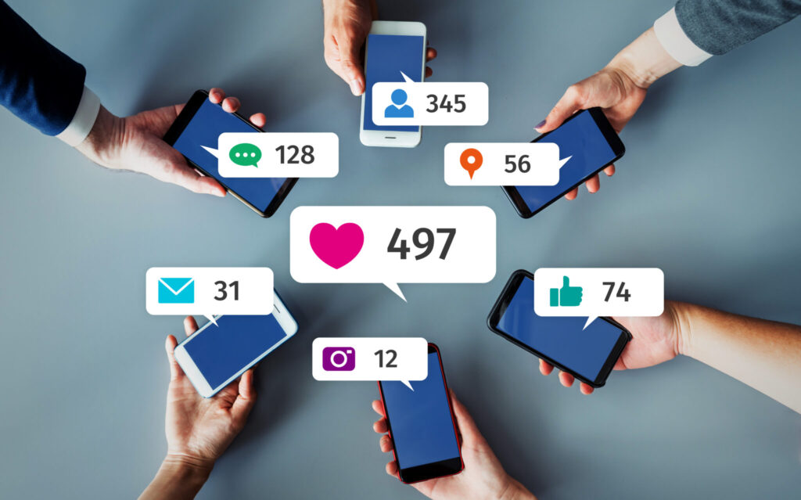

Table of contents

Summary 3

Introduction 3

Wisdom of crowds 3

Going viral 3

Not-so-wise crowds 3

Dialing down engagement 4

Discussion 5

Conclusion 6

References 7

Appendices 8

# Summary

## Introduction

Social media companies make money from people using their platform, if users stay and watch longer, they make more money. That is why social media uses all kinds of algorithms to show you what they think you will like, to keep you engaged and increase the time you spent on their platform. This also means that you might only get to see one side of a topic, which takes away credibility. I am going to write about how and why social media influence might negatively affect you.

## Wisdom of crowds

People like to follow the crowd, this has been baked into our brains by evolution. Taking signals from other people’s behavior and opinions will result in more accurate predictions and decisions. Things like familiarity, exposure and the bandwagon effect will change the cognitive biases of your brain. If everyone does the same thing, even if you don’t know the reason behind what they are doing, it is better to join the crowd and find out the reason later.

Social media will try to exploit these behaviors programmed into our brains. A simple example of this is: if the majority likes something, it is high likely that others will like it as well, so this item will get recommend more often. The previous example is only the tip of the iceberg, the social media algorithm’s will access a lot more information from much larger crowds and process all this faster than your brain ever could.

## Going viral

Not everything that goes viral deserves to go viral. Real news can be boring sometimes, often not getting as many likes as the more sensational fake-news stories that can be found on many social media pages. If this fake news gets more likes, it is more likely to be recommended to you. If you engage in or like false information, the algorithm will keep recommending this false information to you and filter out the real news. As you are getting more exposed and familiar with false information, one day it will start to affect your judgement or the credibility behind your reasoning for the decisions that you make.

All web technology platforms including social media are built on a popularity bias. The way they focus on engagement can lead to unintended consequences, which can be harmful. In general, popularity bias is more likely to lower the overall quality of content. When just a few people make content popular, this will keep getting more engagement, because the algorithm shows the content to more people, it amplifies the engagement of the content. This makes it so that bad content can easily bubble up even if just a few people engage with it.

People are effected by this increase in exposure, evidence shows: “the more times someone is exposed to an idea, the more likely they are to adopt and reshare it”. Following the crowd, people will want to pay attention to viral content.

## Not-so-wise crowds

An experimental game was developed, simulating a social media news feed. Players were shown all kind of articles, and would get points for sharing or liking news from reliable sources and flagging lower credible articles. It was found that players liked and shared content more when popular, while less likely to flag low credible sources. Exposure to the engagement metrics thus creates a vulnerability.

The wisdom of the crowds is build on multiple assumptions that are mostly not true in social media. The crowd should be made up of diverse and independent sources. We associate with similar people, online neighborhoods diverse enough. Your bubble affects you, through the social desire to conform.

Even the algorithms can be influenced, for example by link farms or bots that try to create fake engagement so content that shouldn’t be popular becomes recommended.

## Dialing down engagement

Technology platforms are trying to take down fake accounts and harmful misinformation, but this isn’t very effective. A possible approach would be to add friction, slowing down the process of spreading information, and decrease opportunities for manipulation. Instead of slowing down engagement, social media could also adjust their algorithms to focus on something other then engagement.

# Discussion

Directe/indirecte stakeholder in kaart brengen en persoonlijke rol in ethische analyse

Beslissing naar eigen mening over juiste ethische actie en onderbouw met feiten en argumenten

Voorbeelden over omgaan met iemand anders tegengestelde argumenten

en mogelijke relatie tot BP

# Conclusion

# References

Menczer, F. (2021, 10 september). How ‘engagement’ makes you vulnerable to manipulation and misinformation on social media. The Conversation. Geraadpleegd op 19 oktober 2021, van https://theconversation.com/how-engagement-makes-you-vulnerable-to-manipulation-and-misinformation-on-social-media-145375

# Appendices

bijlage